HOW TO POST YOUR 2020 DAY OF CARING VOLUNTEER OPPORTUNITY
- Go to your Agency Management Area and click the Advanced Events link.
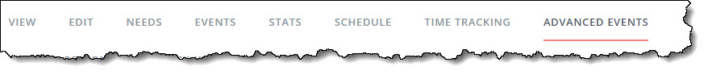
- Click the option that corresponds to your volunteer opportunity type: Volunteer Opportunity or Wish List
- Answer all applicable and required fields on the Need Information page. This page has several sections, listed in the table below.
Note: Your response may prompt a field for further information. For example, if an event is outdoors, you'll be asked to provide inclement-weather details. All information entered in this section, including additional notes (such as inclement weather plans), will be visible to the volunteer.
Section of Need Info Page | Description/Notes
Basic Information | Title, Interests & Abilities, Date, Hours, and Duration are required.
Volunteer | The only required field in this section is # of Volunteers. Enter a specific number (not a range). Optional fields are Allow Team Registration?, Minimum Volunteer Age, and Minor Requires Adult? This information will be shown in the volunteer view.
Location | An address is required.  Note: If your opportunity is virtual, please add a note in the Directions field that this volunteer opportunity can be done in the comfort of their home.
Additional Information | Use this section to provide further details about the need: Outdoors, Handicapped-Accessible, Family Friendly, Tools Required, Drinks Provided, and Meals Provided.
Contact | This section is provided for the volunteer who may have questions about the event. When a volunteer responds to a need, the automatic notification will go to the agency or program manager--not to the individual entered here (unless, of course, that individual is also an agency or program manager).
Description | Type a succinct need description.
- Click Create Need. Your need will now be listed on your Advanced Events page.
Note: The "clock" icon above shows that the need is pending. All advanced-event needs must be activated by site manager before it can be made available to volunteers. You can, however, edit the need once it's been submitted. You can also clone the need. After a need has been activated, you can view the number of volunteers who have responded, add new respondents, and reach out to your volunteers.

Your listing then should be viewable online at: https://volunteersheboygan.galaxydigital.com/aem/general/

Questions:
Email katelyn@uwofsc.org or volunteer@uwofsc.org

