January 19, 2024

SPIRIT OF SHEBOYGAN COUNTY VOLUTNEER AWARDS

This annual awards luncheon celebrates individuals, groups, and companies that epitomize the spirit of giving throughout the year.

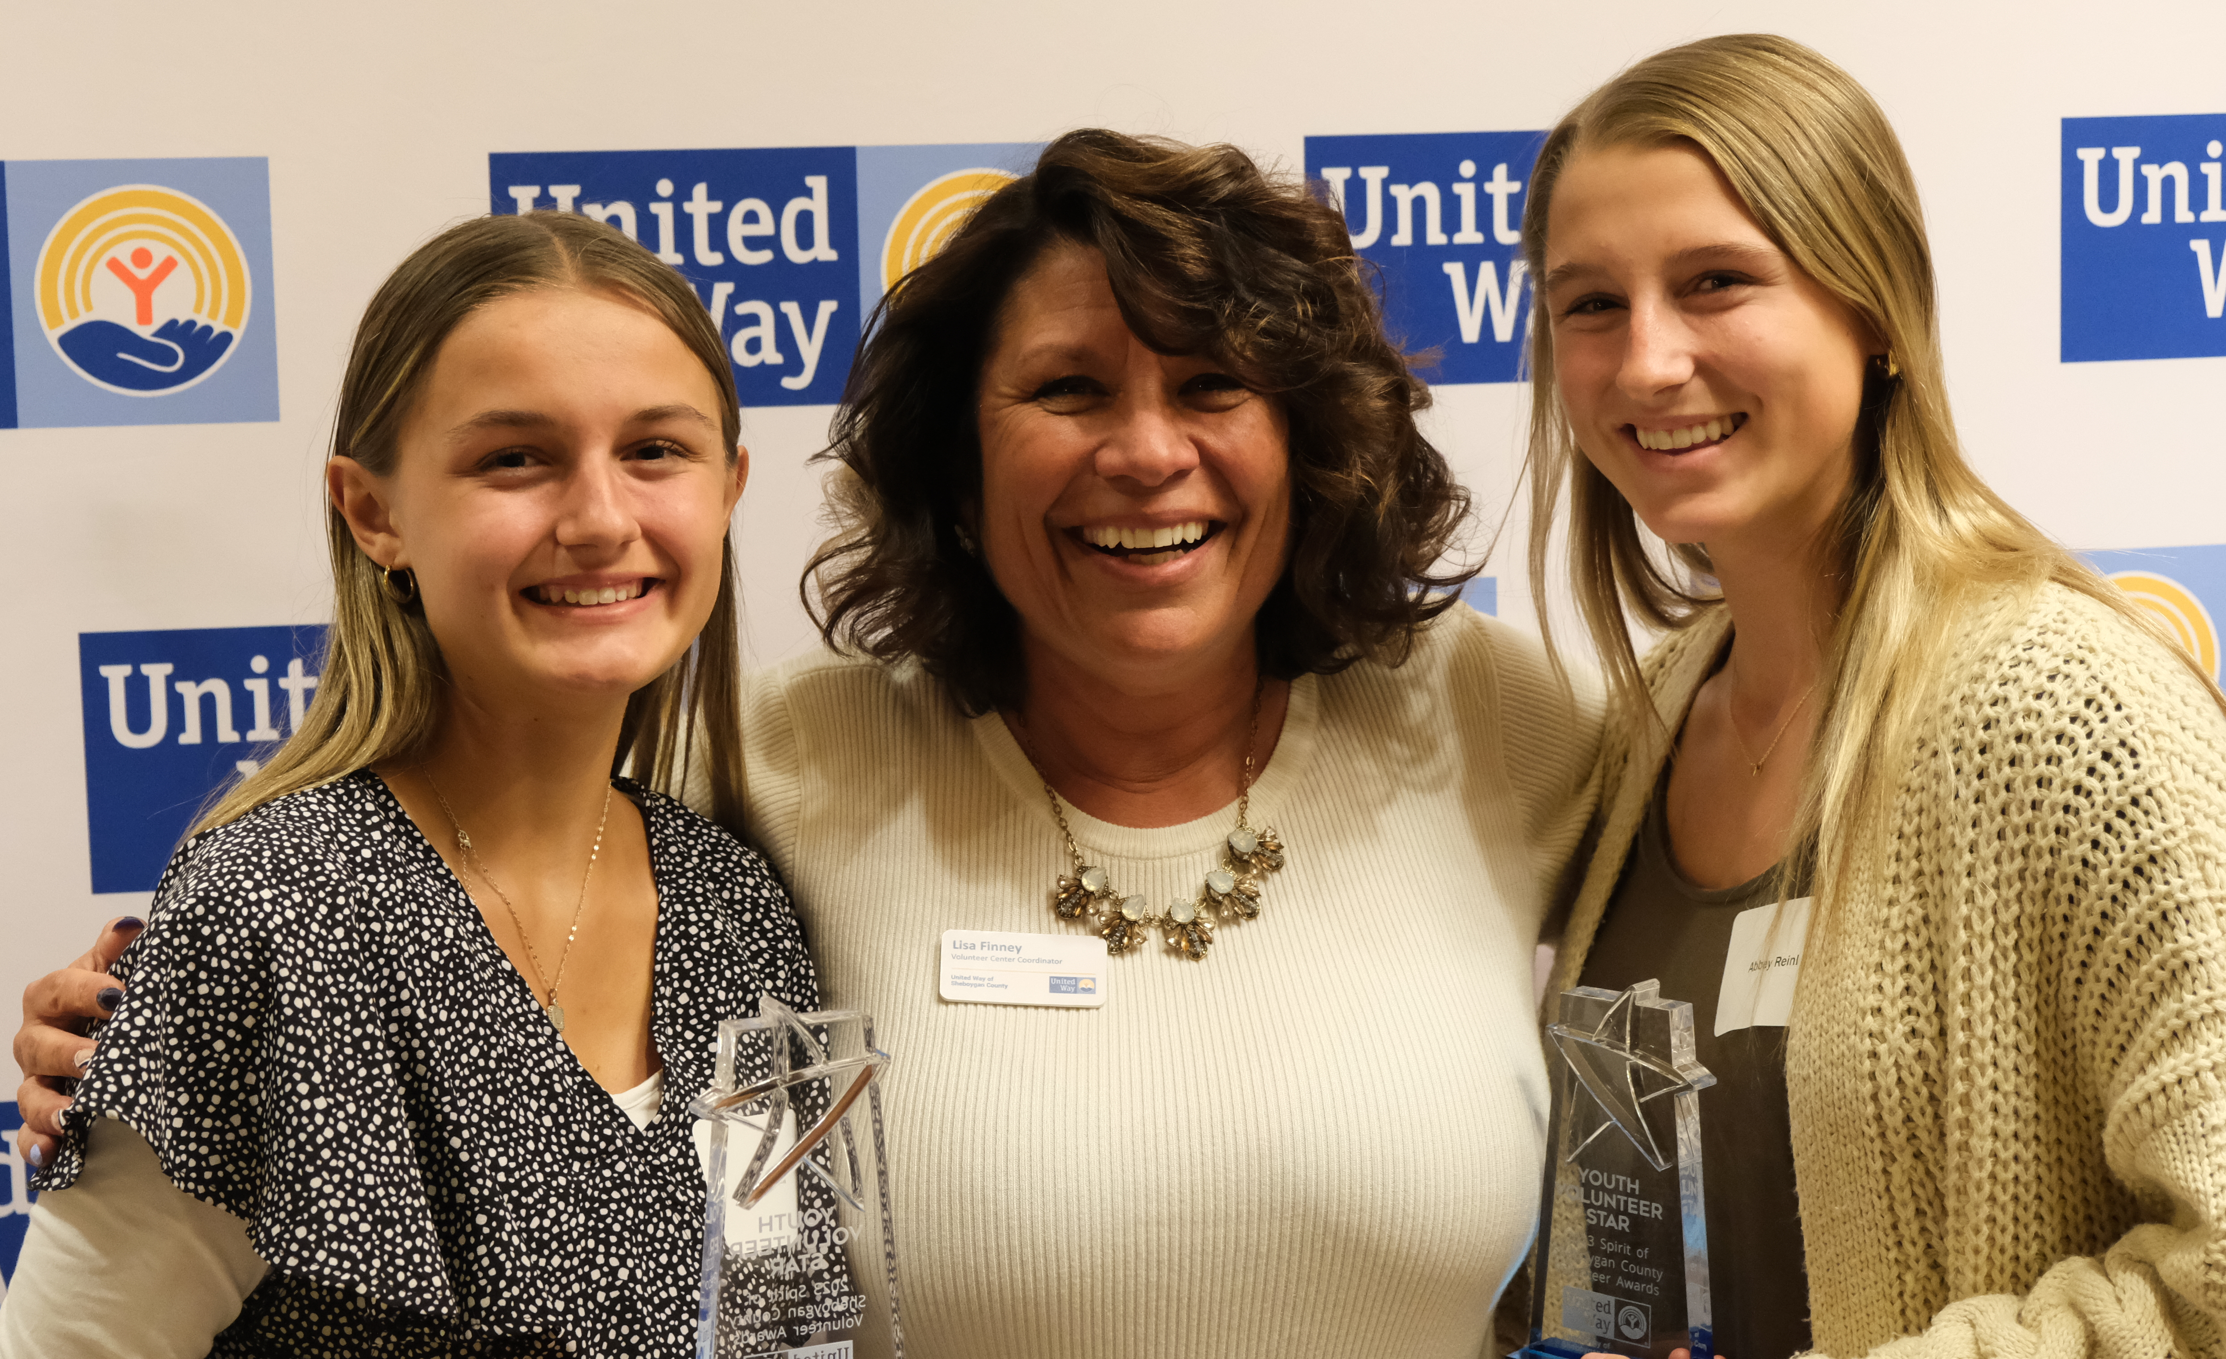
2023 Youth Volunteer Star Award
winners Abbey and Lilly Reinl pictured with
Volunteer Center Coordinator, Lisa Finney.
Visit uwofsc.org/vc for the award categories, nomination details, and a full list of last year’s winners!
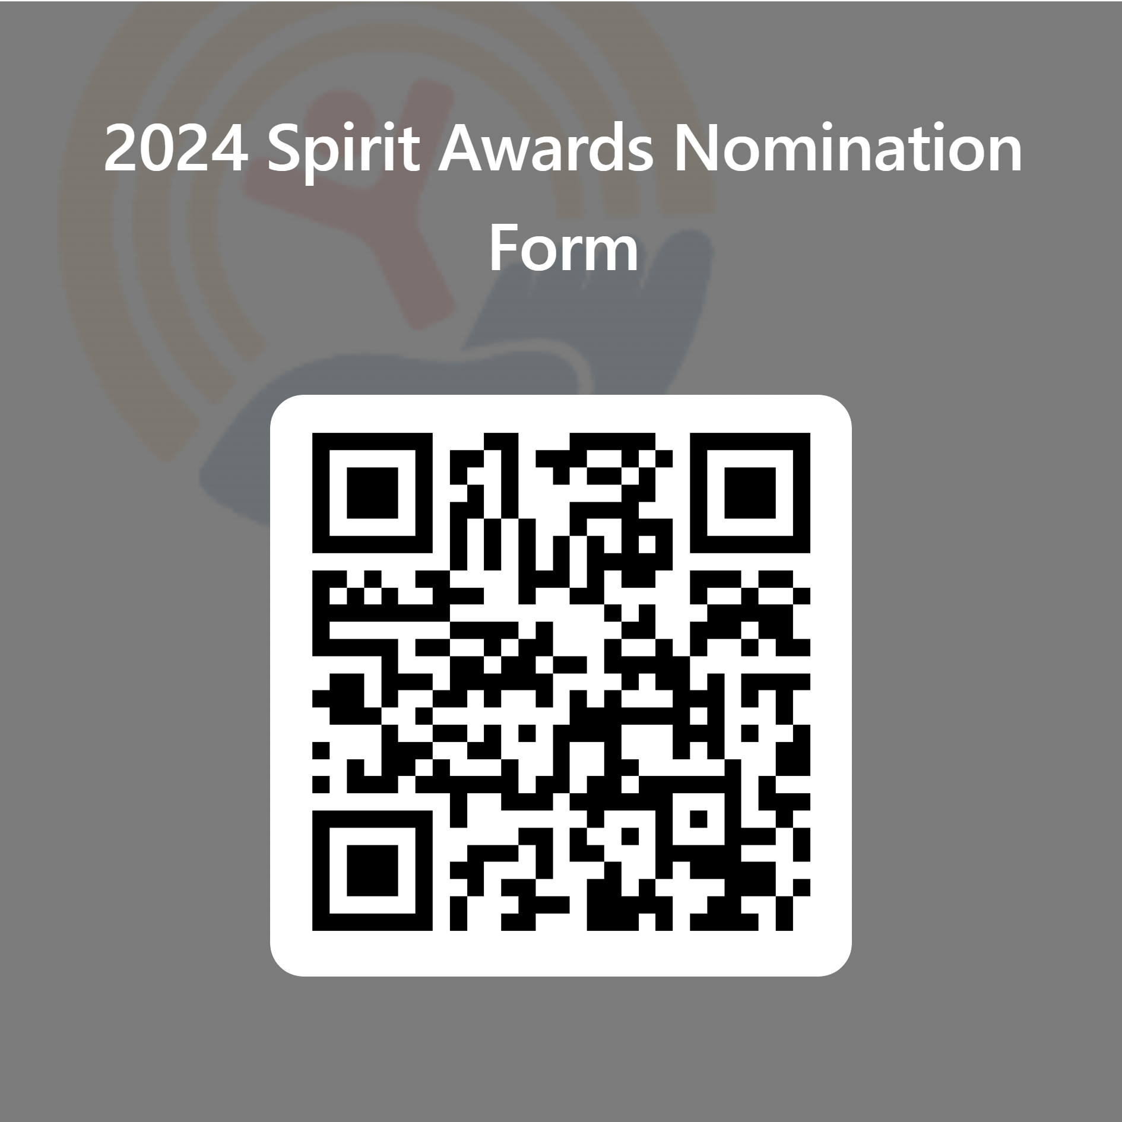
Nominations are
due February 6th, 2024.
Questions? Call Lisa Finney at 920-458-3425 or email her at lisa@uwofsc.org.

Greetings!
Please join us in celebrating the incredible volunteerism occurring in Sheboygan County. United Way of Sheboygan County (UWSC) is excited to host the 8th annual Spirit of Sheboygan County Volunteer Awards at the American Club for a luncheon on Friday, April 25th, 2024.
This awards ceremony recognizes the wide breadth of individuals and groups giving of their time and talents to make our community a better place to work, play, and live. Through their gifts, volunteers further the missions of local nonprofits and provide valuable support to the others in times of need.
Your sponsorship will elevate the work of all volunteers, honor the nominees, and inspire volunteerism throughout our communities.
All sponsors will receive substantial recognition before, during and after the event. To ensure that you receive all the marketing opportunities available, please confirm your sponsorship by April 5th.
Thank you for your consideration. Please do not hesitate to reach out with any questions.
United in Volunteerism,

Lisa Finney
Volunteer Center Coordinator
920-458-3425 | lisa@uwofsc.org

Spirit of Sheboygan County Volunteer Awards

Sponsorship Levels

Sponsorship Benefits | Gold  $2,500 | Silver  $1,000 | Bronze  $500 | Partner  $100
Listed as an award sponsor, with company name on award (of your choice) and opportunity to present the award at the event ceremony  *Limited opportunities – First come, first serve basis on the choice of award | ✓
Company announced at event and mentioned on air during one of United Way’s weekly radio spots on WHBL and B93 | ✓ | ✓
Company logo on tables at the event | ✓ | ✓ | ✓
Company logo on main event banner | ✓ | ✓ | ✓ | ✓
Company acknowledgments on digital marketing, such as on social media, website, and e-newsletter | ✓ | ✓ | ✓ | ✓

Special thanks to the Awards Advisory Committee Members
Alec Bartolai, Sargento Foods Inc | Nicole Brown, Kohler Co. | Kirsten Coenen, Kohler Credit Union
Marquita Norton, Johnsonville Sausage | Sara Spicer, Collins State Bank
Johannah Wenig, HSHS St. Nicholas Hospital| Michelle Zuengler, HSA Bank

Spirit of Sheboygan County Volunteer Awards

Sponsorship Form

Company Name _______________________________________________________________________

Company Address _____________________________________________City__________ Zip_________

Contact Name __________________________________

Contact Phone _________________________ Contact E-mail ________________________________
Yes! I want to sponsor this event at this level:

_____ Gold $2,500 _____ Bronze $500

_____ Silver $1,000 _____ Partner $100

Please make checks payable to, and return with form, by Friday, April 5, 2023 to:
United Way of Sheboygan County
2020 Erie Ave.
Sheboygan, WI 53081

We will follow up with the contact listed above after we receive this form.

Sponsorship Questions? Call Katelyn Piper at 920-458-3425 or via email at katelyn@uwofsc.org.

Thank you for your commitment to our community!

