  - Volunteer Center Network Update: June 22, 2022
2022 DAY OF CARING – MESSAGE TO THE VOLUNTEER CENTER NETWORK
Day of Caring serves as a day businesses and individuals connect with nonprofits through filling various volunteer opportunities. On this day, volunteers have a chance to connect with your mission and our hope is that you will build new relationships that will lead to ongoing volunteers and/or lasting advocates for your agency.
Below includes the planning process for 2022 Day of Caring. Please reach out to us if you have further questions by calling 920-458-3425 or emailing volunteer@uwofsc.org.
THURSDAY, SEPTEMBER 22, 2022 EVENT INFORMATION
- Kickoff Event: UWSC’s Campaign and Day of Caring Kickoff event will be on the Sheboygan County Fair Grounds in the stadium. Event structure includes:
- 7:30a - Fair Grounds open for parking (229 Fairview Dr. Plymouth WI 53073). Parking details coming soon.
- 8:00a - United Way Program with grab and go bagged breakfast
- 8:45a - Program ends and volunteers leave for their projects

- Volunteer Opportunities: Register your opportunities for Day of Caring through ‘advanced events’ through your login. Morning volunteer opportunities will be 9:30 a.m. to 12:30 p.m.; Afternoon volunteer opportunities will be 1 p.m. to 4 p.m.; and All-Day volunteer opportunities will be offered from 9:30 a.m. until 4 p.m. If you are offering a full-day volunteer opportunity, you must offer lunch to the volunteers. *Instructions are on the next page.
- Acts of Kindness Challenge will continue to be another way community members can engage in UWSC’s Day of Caring. The purpose of this challenge is to encourage giving back in even the smallest of ways as we know sometimes it is the little things that can make a BIG difference. The kindness actions listed in this challenge are meant to be fun and thoughtful activities to promote and celebrate shared moments of happiness. This challenge will be promoted throughout the county through United Way’s business campaign contacts and have an adjacent social media campaign for anyone to engage in.
- NOTE: All types of volunteering listed online will be highlighted on the Acts of Kindness Challenge idea list.
- Pre-Event Timeline:
  - Friday, August 5th – Volunteer opportunities open to sponsors
  - Thursday, August 11th – Sponsorship deadline for full benefits & signage
  - Friday, August 12th – Volunteer opportunities open to the public
  - Week of August 22nd – Agencies pick up their event signage
  - Friday, August 19th – Deadline for a guaranteed t-shirt for volunteers signed up
  - TBD – Volunteers pickup their t-shirts at United Way of Sheboygan County
  - Wednesday, September 7th – Virtual Pre-Event Meeting with VCN (if necessary)
  - Thursday, September 22nd – DAY OF THE EVENT!
- Pivot Plans:
- If recommendations by the CDC or Sheboygan County Public Health change, UWSC will host the kickoff event in the morning virtually on the same day.
- All agencies are responsible for a backup plans for each of their projects.

How to add an opportunity for 2022 Day of Caring:
- Log into your account
- Click on ‘My Agency’ on the top window
- Click ‘Advanced Events’
- Then click on the corresponding type of volunteer/giving opportunity you want to list:
  - 2022 Day of Caring: In-Person Opportunities
  - 2022 Day of Caring: Wish List Opportunities
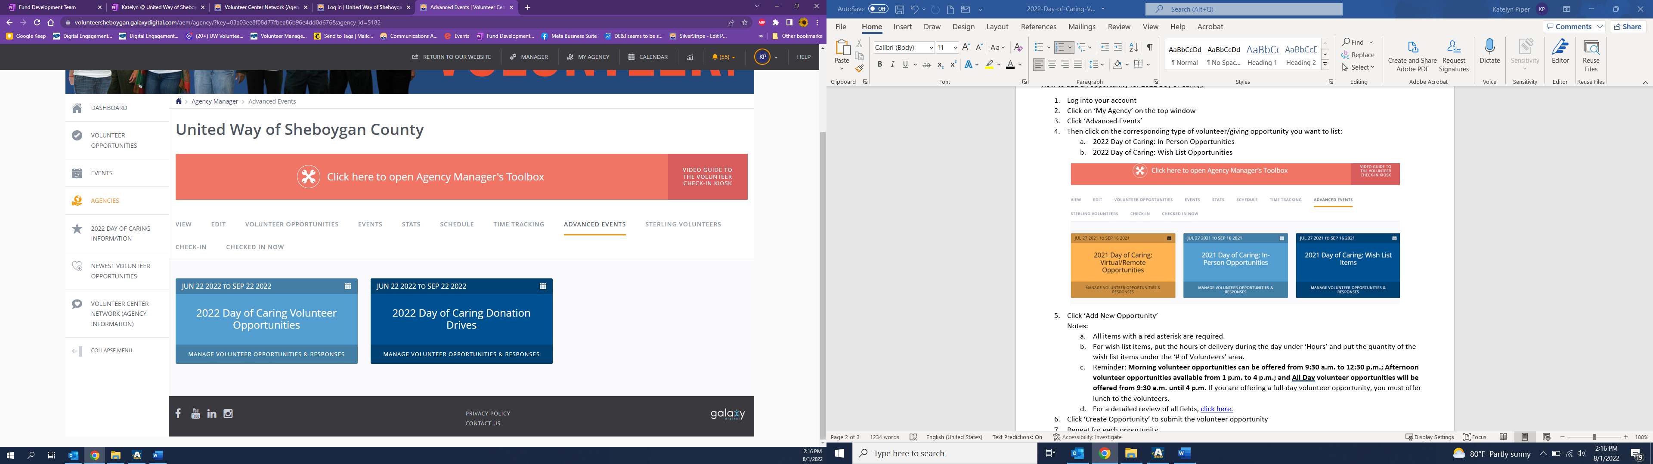
- Click ‘Add New Opportunity’
Notes:
  - All items with a red asterisk are required.
  - For wish list items, put the hours of delivery during the day under ‘Hours’ and put the quantity of the wish list items under the ‘# of Volunteers’ area.
  - Reminder: Morning volunteer opportunities can be offered from 9:30 a.m. to 12:30 p.m.; Afternoon volunteer opportunities available from 1 p.m. to 4 p.m.; and All Day volunteer opportunities will be offered from 9:30 a.m. until 4 p.m. If you are offering a full-day volunteer opportunity, you must offer lunch to the volunteers.
  - For a detailed review of all fields, click here.
- Click ‘Create Opportunity’ to submit the volunteer opportunity
- Repeat for each opportunity
- UWSC will make opportunities available for sponsors on August 5th and to the public on August 12th.
Once your volunteer opportunity is LIVE to the public, they will show up here: https://volunteersheboygan.galaxydigital.com/aem/general/

VOLUNTEER ENGAGEMENT IDEAS FOR DAY OF CARING

Here are a few ideas to consider while hosting volunteers during Day of Caring:
- Connect with them ahead of time! Check in with the team lead or individual volunteers to give them a heads-up on what to expect and share your excitement that they chose your agency for this year’s Day of Caring.
- Take the volunteers on a Tour! Walk them around your building or space to help them visualize the amazing services you provide our community. Encourage them to ask questions and make sure to mention ongoing needs that you have that will hopefully inspire them to come back and fill!
- Ask current volunteers to help out that day, so they can help you recruit ongoing volunteers! Ask them to connect with one or two volunteers to learn more about them and how they could help your organization in the future.
- Teach them a something new! Many volunteers site one of the benefits to volunteering is learning a new trade. Take them through an activity you provide your clients or teach them something that volunteers help your agency with on a regular basis so that they have a taste for what they would be doing if they came back to volunteer with you.
- Document the Day! Take pictures of them volunteering and make sure to get a group shot to share on Social Media so you can thank them publicly!
- Provide a Thank You! This could be in the form of a snack, thank you, or other treat from your organization.
- Make the Ask! Make sure to ask the volunteers if they would come back. Don’t ask your volunteers to help your organization, but the cause. Inspire them with stories of real people they would be helping and real challenges that their work addresses.
- Follow-up! Thank the volunteers and provide them with an easy reason to come back or stay in-touch with the impact your agency is making in our community. This could be by providing a link to sign up for an event or volunteer opportunity you have coming up.
FAQs
- I can’t get into my login, what should I do?
Each agency must have an individual login that we ‘attach’ your agency listing to (similar to Facebook).
  - If you do not have your own login, email volunteer@uwofsc.org for help to get set up and connected to your nonprofit agency’s listing.
  - If you forgot your password, click the ‘forgot password’ on the sign-in page or email volunteer@uwofsc.org.
  - Note: This is a great time to clean up any past employees still connected to your agency listing. Let us know and we can remove any past employees and add new ones.
- Can I copy volunteer opportunity from the main page to Day of Caring?
Unfortunately, no. At this time the website doesn’t have a ‘clone’ option for ‘Advanced Events’ such as this.
- How do I communicate with United Way staff the day of the event?
The UWSC team is out in the community on this day, so the best way to communicate is to email info@uwofsc.org or call 920-458-3425. You can also message the team on UWSC’s Facebook page.

